9th November 2018
Kieran Bond
University of gloucestershire
S1504020
An investigation into improving user experience through game camera implementation

Contents
Introduction 1
Context 1
Definitions 1
History 1
The issues 1
What we’ll look at 1
Literature Review 2
Importance to the designer 2
Why it’s important 2
Creating atmosphere 2
Cinematic Pieces 3
Aiding the Designer 3
Developing Parameters 3
Level Design 4
Different views 4
Player interaction 5
Types of interaction explained 6
Impact on Player 6
Solving the problems 6
Output Design 8
Specifications 8
Justification and thesis link 10
References 11

Introduction

Context
‘Nothing will cause players to stop playing your game faster than a poor camera’ (Rogers, 2014).

Definitions
A games camera in its simplest form is the presentation of the game to the player, it is an ‘abstract construct’, as defined by Haign-Hutchinson (2009, p. 26). This definition is validated by Kremers (2009, p. 199) who says, ‘The camera system of a game is a medium through which we view the game directly’. Technically, the camera is referred to as the viewpoint or viewport.

History
Since the first ever video games, the game camera has existed. ‘The viewpoints for the first video games were limited, and they were mainly limited to text descriptions’ (Fullerton, 2014). Cameras since evolved, but in early games, ‘the camera tended to be locked down’ (Mitchell, 2012) and simply used as the tool to render the screen. Cameras have since progressed to become ‘an important consideration for storytelling in games’ (Totten, 2014), a tool that can be used to elicit emotion and response from the player.

The issues
‘If a complex camera is needed for the game, but it is not worked on and respected from early on in the project, you are in real trouble’ (Kremers, 2009). If camera design for a game is not given considerable thought or planning, it can lead to ‘a host of problems’ according to Meigs (2003, p. 98). Issues of the camera system often stem from early on as the ‘camera will be fudged into the game at the beginning of the development’ (Oxland, 2004), ignoring that ‘it is of the utmost importance that the subject of game camera be taken seriously’ (Kremers, 2009).
The forgoing of camera design at the onset can lead to issues later in development when the game designs have been modified, or when the playtesting shows there are issues with the camera system. This can lead to features being removed or modified to allow time for the camera or level design changes to be completed and fix issues found.

What we’ll look at
Further in this research, we will look at why the camera is important in the presentation of the game to the user. We will also look at why camera design is important for the game designer.

Aims and Objectives
The aims for this research project are as follows:
- To develop an understanding of the needs of a designer when creating a video game in relation to the camera system.
- To accumulate a breadth of knowledge surrounding how to create a camera system that avoids common pitfalls displayed.
- To develop a thorough understanding of the variety of uses for game cameras.
The objectives for this research project are as follows:
- To conduct a thorough review of appropriate academic literature to establish the key issues found in video game camera systems.
- To develop an appropriate example of an appropriately designed camera system that aids designers in the creation of video games.

Literature Review

Importance to the designer

Why it’s important
The camera is a powerful tool for a designer to utilise and has an ‘enormous influence over the final quality of the game’ (Kremers, 2009). Designers can use this tool to create atmosphere, they can use it to create cinematic sequences, they can also use it to give freedom to the player. They can use it as a tool that shapes the entire experience to the player, whether subtly with a smart design so the player does not fight with it or through creating well-choreographed cinematic experiences.
‘Getting the camera right can make all the difference in playability’ (Meigs, 2003). Often, the camera is overlooked as a tool. It is often seen as just a piece for the player to control, rather than what it truly is – an ‘important consideration for storytelling in games’ (Totten, 2014). This is not to say that its control should be neglected. ‘The control of game cameras is important because it fundamentally defines how the player experiences the game’ (Haign-Hutchinson, 2009). Haign-Hutchinson (p. 23) also reminds us that it is not always the case that cinematography is appropriate or will be successful.

Creating atmosphere
Often, game cameras are compared to cameras in movies. Oxland (2004, p. 139) makes the point that in games ‘we can do things with cameras that movie people can’t do in reality’, which suggests that whilst they are alike, game cameras have now extended upon the abilities that movie cameras have – that was back in 2004. Totten (2017, p. 72) furthers this point by stating ‘a game’s virtual camera is computational and dynamic, its functionality extends far beyond that of a film camera’. Designers can use the camera as a tool to create atmosphere and cinematic sequences, they can use the camera to provide an emotional impact onto the player. To a designer, the camera can be a cinematic tool rather than a throwaway item. Schell (2015, p. 3) tells us that if you want to deliver an emotionally compelling experience, you need to understand the art of cinematography.
Oxland (2004, p. 138) contrasts this point with ‘we don’t know how to use them. We are not cameramen or movie directors’ and that is the reason why ‘cameras are rarely in the right place at the right time’. Oxland (2004, p. 139) appears to have more of a view that the camera is simply a tool for the User to manipulate but does believe that ‘we’ll eventually see games mastering the art form’.

Cinematic Pieces
Using cinematic views allows designers to create more aesthetic game visuals and emphasise drama within the game, Rogers (2014) refers to using ‘Hollywood-style camera angles and shots’ to provide this effect. This is further supported by Haign-Hutchinson (2009) who believes that cinematographic conventions should be observed when trying to implement cinematic sequences. Designers should remember that the ‘look and feel of games can be dramatically affected by the placement of the camera’ (Mitchell, 2012) and not forget to use it for this purpose, as well as for its cinematic capabilities.
Designers can follow cinematography practices and conventions to provide their game with set pieces that enhance the players experience, they can also work with other developers so that their game cameras can follow these practices in real time. Camera work in games has ‘obvious parallels with film’ and so it can be recommended to spend time researching camera use in films for providing effect, although keeping in mind that there are sometimes ‘differing aesthetic requirements’, as told by Haign-Hutchinson (2009). Designers should keep in mind that whilst these camera abilities can look great, they can also hinder the player if overused – this is supported by Kirby (2011) who tells us that ‘camera AI is a powerful tool that needs to be used carefully’. A glance at earlier games, particularly early 3D games, is a great way to learn what not to do with the camera. Early 3D games often had hard to predict cameras that were trying to provide a more cinematic experience but instead became a frustrating experience for the player (Kirby, 2011).

Aiding the Designer

Developing Parameters
Often, a designer is not working alone. A designer is usually part of a team, and if working on their games camera they will likely be working alongside a developer who can make changes to the camera systems code. It’s imperative that the designer and developer work together to avoid cameras that ‘want to kill players’, a notorious problem according to Totten (2014) due to the difficulty in making Camera AI. To avoid difficult cameras to refine and playtest, the developer can give the designer more control by giving them modifiable parameters that the camera AI makes use of. Haign-Hutchinson (2009) believes that ‘data-driven solutions’ offer this control but do come at the cost of higher maintenance and learning curves, this in turn could equate into more time and thus money investment into the camera system.
Some properties that the designer may want to modify, whether in real-time or otherwise are properties such as the movement speed of the camera, the cameras field of view, the offset in relation to the player or the position of the camera.
One potential method for the designer to edit properties in real time is a method known as ‘camera hints’ which is defined by Haign-Hutchinson (2009) as ‘scripting mechanisms that allow designers to temporarily override or alter existing camera behaviour within a specific area of the game’. Camera hints allow the designer to modify the behaviour of the camera in specific areas or situations, to ensure that the player gets the best experience at all times. These hints can also be used when the designer wants to create a cinematic piece in real-time and by having camera hints within the tool, the designer has more control over what and how the player becomes immersed into the game.

Level Design
‘For game designers, the relationship between camera and object position can be a powerful tool’ (Totten, 2014).
Utilisation of the camera to provide immersion and dramatic effect, is not always reliant on the developers working on the camera nor the designers manipulating the tool. Level designers can highlight the narrative with their levels and use the game’s cinematography to aid in the storytelling, as noted by Totten (2014). Haign-Hutchinson (2009) tells us that ‘Camera design inherently affects environmental design’, and this is due to how the camera AI has to work with environments and the player movement. Level Designers can design the level with the camera in mind and avoid potential issues with the camera, if they are aware of the cameras design and implementation although this is a ‘complex undertaking in a real-time environment’ (Meigs, 2003).
Level designers can work with the Camera developers to enhance the user experience and create levels that do not interfere or integrate poorly with the camera. Working together will provide a less frustrating experience.

Different views
Throughout the history of games, different viewpoints have come and gone. Designers have choice over which viewpoint or view style to use for their game and each has different benefits and negatives associated with them. The Designer will likely have a style in mind for their game, based on the genre of the game – but this is not always the case.
The style of view used by the designer will affect the AI needed on the camera, if any is needed. This in turn affects what problems are common and are likely to occur during development. The most popular style of views used in 3D games are third-person and first-person.
Third-person viewpoints are plagued with many common AI problems but are still very popular. They remain popular as the common issues are known and solved, as well as the benefits that come with third-person views usually outweighing these problems. Third person views are often not as immersive as first person views but can make the relationship between the character and their environment easier to see, allowing for greater interaction and sometimes control of the character. Third person views are also able to provide more cinematic and dynamic views, which is often desirable for the Designer.
The downside to third-person views is that they are usually less immersive, as well as often cumbersome to control by the player. In earlier implementations of this camera, it was a common occurrence to be able to move the camera outside of the game world which could lead to abuse by the player in beating the game. Third-person views usually require more time to be worked upon to make them bug free, as camera AI is ‘notoriously difficult to code well’ (Totten, 2014).
First-person viewpoints are often used for games that want a more immersive experience, and is often called the ‘traditional’ view as the game is perceived from the eyes of the protagonist, sometimes also known as point of view (Haign-Hutchinson, 2009). First-person views are often used in first-person shooters (FPS) and Role-playing games (RPG). FPS games use the first-person view often for the reason that they excel in representing the players control movements when ‘aiming’, as noted by Totten (2014). On the other hand, RPG’s often use first-person because it can benefit the gameplay through immersion. First person viewpoints often have less AI requirements as they’re usually fully controlled by the player and don’t need to do things such as environment avoidance. This allows the designer to focus on other aspects of the camera such as providing screen-space effects or working on other aspects of the game.
Some first-person games counter the sense of immersion due to not showing enough of the character the player is controlling – this is because it does not feel like the view is from the protagonist, through their eyes they would be able to see their bodily parts. A limitation to the first-person view is that there is usually a smaller field of view compared to something such as the third-person view style, and this can make it hard to understand the environment and the players positioning within the environment.

Player interaction
‘Bad things happen when players are given control of the game camera’ (Rogers, 2014). Player interaction with the camera is an important feature not to be done poorly, if included in the game. Kirby (2011, p. 293) tells us that cameras can have two types of AI and thus interaction; AI on behalf of the designer, and AI on behalf of the player.

Types of interaction explained
Camera AI which is on behalf of the player is often an interactive camera that the player controls, with AI programming to make it appear ‘smart’. It usually allows the player to manipulate its position and orientation and can be reactive to the environment - particularly when in a third-person view. This can ‘present interesting problems to the camera AI’ (Kirby, 2011).
The other type of AI for cameras, on behalf of the designer, is aimed to ‘achieve dramatic impact’ (Kirby, 2011). Camera AI of this kind can be used by the designer to aid the player, it gives the designer control over the players view - ‘Without camera control, you don’t risk players missing anything important in your game’ (Rogers, 2014). This type of camera is also often used when designers want to ‘enhance a game, including in the area of immersion’ (Kremers, 2009). This type of camera gives the designer more control over what the player sees, and more importantly, how they see it.

Impact on Player
The type of Camera and its respective AI should not be a decision taken lightly, due to the impact it can have on the player and the players experience. It can be easy to forget that ‘effective camera AI adds to the player’s enjoyment’ (Kirby, 2011). Whilst considering the design, the impact that the camera has on the player should be taken into consideration as the players experience of the game is fundamentally defined by how the camera is controlled (Haign-Hutchinson, 2009).
There are mistakes that are commonly made with cameras that impact the player, one such mistake is too much camera jumping. This problem can cause the player to become easily disoriented or confused and so breaks the fun experience (Meigs, 2003). Another common problem is when cameras get ‘stuck’ – this can be stuck in the environment, or potentially the AI gets stuck and is unsure how to provide the best view. This can result in player dissatisfaction as the movement or reorientation of the camera will be inadequate for viewing the players character (Haign-Hutchinson, 2009).
To provide an impact on the player, cameras can be used to provide immersion and invoke emotions. Designers can forget to use the camera as a tool in this capacity, and this is a mistake – the camera is one of the greatest tools for these concepts. Designers can provide this by opting to use the camera cinematically, as if in a film, or they can choose how their viewpoint is related to the player to aid in providing effect.

Solving the problems
Games can contain well designed and well implemented camera systems. These games will likely have designed their cameras early in their development, as well as performed early testing of the systems. Not all games however will do this, and thus will come across problems.
To provide well implemented cameras, developers will likely have to solve the common mistakes as detailed before. The first solution to common mistakes, is to remember that ‘you don’t need anything fancy to move a camera around’ (Rogers, 2014). Another solution offered by Rogers (2014, p. 159), is to ‘never let the character get out of the camera’s sight’. This second solution can often be hard to provide when the player is in a small environment, in third person views particularly, but is often mitigated by allowing the walls of the environment to become transparent to the camera. Meigs (2003, p. 98) expands on this problem by offering the solution of automatic camera movements to allow avoiding transparent walls and the issues that come with them.
These solutions can solve some problems that cause player dissatisfaction but will not fit every problem that occurs. Some games can struggle with the problem of creating immersion or providing a dramatic effect with their cameras and whilst there is no one solution for this, some solutions can be offered.
An important solution to the issue of creating emotional games and creating immersion is to have a powerful camera-tuning system - as noted by Meigs (2003, p. 100). A powerful camera system will allow the designer to modify the rules in play by the camera, as well as create cinematic set pieces, refine camera moves and ‘build up the kind of gameplay your team has as a goal’. Totten (2014, p.146, p.147) recommends first-person or fixed perspectives for creating immersion and cinematic views. Although it is noted that whilst they can increase the effect needed, they can come at the cost of ease of control – A loss of control can lead to immersion breaking and frustration to the player, so should be dealt with early on and designed for to avoid these problems.
Games of the Platformer genre, particularly when in 2D, have their own set of problems to solve. Rogers (2014), offers a solution which can solve some problems regularly found in Platformers. Rogers informs us that the camera should never let the character get out of sight this is because if the player gets out of sight, they then lose control of their character thus leading to them becoming frustrated. Rogers also talks about the ‘most basic guideline for composition’, the rule of thirds. The rule of thirds is often used in cinematography and photography and is used to draw attention to areas of the screen. To use the rule of thirds, ‘the focus point of an image should be placed along one of the third lines or one of the four intersections of the third lines’ (Amirshahi et al., 2014).
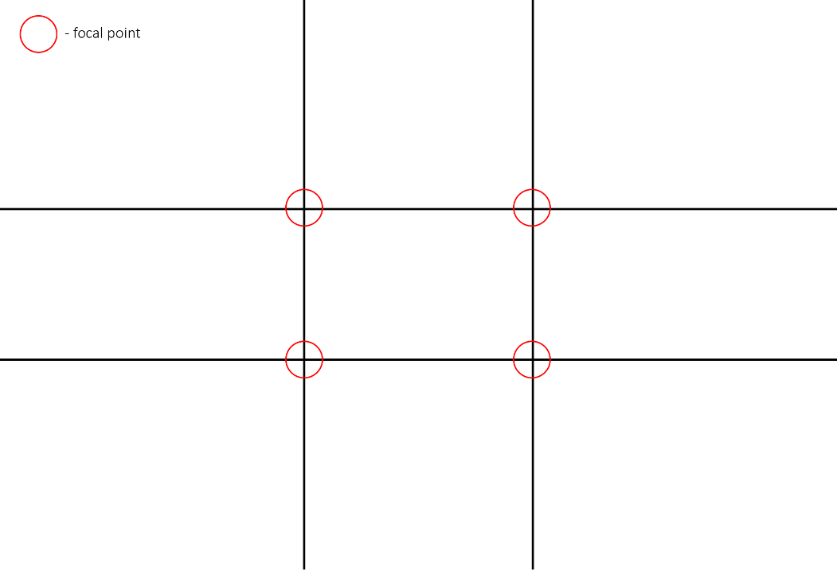
Figure 1 - Rule of thirds and focal points
Platformers can use the rule of thirds to aid the player and allow them to see that which is beyond the characters eyesight. Totten (2014) believes that it is important for side scrollers to practice their own type of ‘visual level metrics’, items such as obstacles, enemies and enemy projectiles should have enough time to be processed by the player from when they enter onto the screen to give the player a chance. To aid the player and give them the time they need to process these items, the rule of thirds can be put into place. Using the rule of thirds, you can put the player in a more aesthetic position of the screen, as well as this foresight – assuming the camera faces the same way as the player.

Output Design
To support this research, a simple platformer game will be created, with two cameras – One camera is a basic system, and the second with a more complicated and developed camera system.
The design of these cameras will be influenced by two articles by Heizmann (2017) and Keren (2015)

Specifications
For the basic camera system, the camera will simply follow the player and keep them in the centre of the screen. This includes when they jump up into the air and will not contain any smoothed movement for when the player starts or stops running or lands from a jump.
For our advanced camera, some rules will be implemented. These rules will make the camera feel alive and smart to the player, aiming to aid them as well as provide a smoother feeling gameplay loop.
The advanced camera will declare a few parts of the screen; the focus zone, the panic lines and the screen centre. All of these, except the screen centre will be adjustable to the designer.
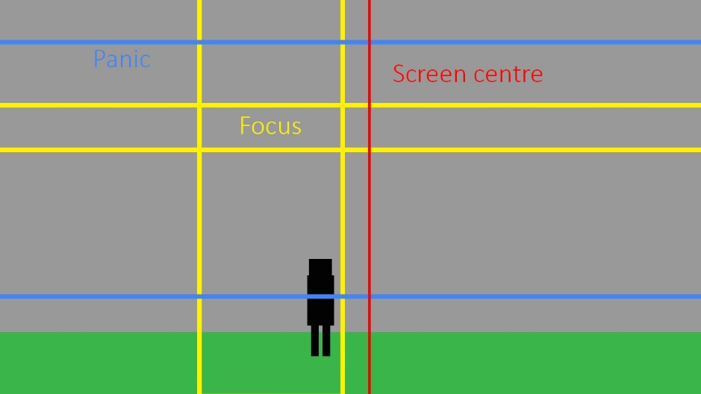
Figure 2 – Advanced Camera Screen Zones
The focus zone determines whether the camera needs to move. Once the player leaves the borders of the focus zone, the camera begins to catch up to the player at a smoothed speed to effectively give the camera a lagged movement.
The panic lines will determine when the player has moved too far away from the camera. This can only happen vertically, but once the player has moved past these the camera will perform a very fast smoothed movement to catch up to the player and return to the correct position.
The screen centre line is there so that we know we are never going over this. The player should always be on the left or right side of the centre, giving us a centre offset – aiding in cinematic effect but also providing benefits.
To keep the player at a centre offset when moving, we lag the focus zone behind the player’s movement. This provides us with smoothed movement constantly whilst the player is moving in any direction. The focus zone will move further off-centre as the players horizontal velocity increases. This should prevent frustration by appearing to adapt to the players intentions.
We’ll also need to ensure the camera ‘looks’ in the same direction as the player. To do this, we can keep the player off centre and move the focus zone to behind the player’s facing direction. This also allows the gameplay to benefit by providing the player with an extended view in front of their direction.
To avoid the jarring effect that will be seen in the basic camera, the advanced camera will not be following the player directly when performing vertical movements such as jumping. The advanced camera will avoid moving on the vertical axis unless the player leaves the panic zone or has landed on an object outside of the focus zone’s horizontal lines. This again will provide the camera with behaviour that appears to predict the player, but will also still keep a cinematic appearance when the player performs certain movements.

Justification and thesis link
The justification for this output design, is to show the effect that a smart camera system has on the playability.
Whilst a game is playable with the basic camera system, it will be painfully awkward to control at times. The advanced system will provide a more cinematic feeling to the game as well as make the controls feel more fluid and responsive. The advanced system will likely have issues, but these can be much more easily mitigated with level design or further changes.
It is likely that the basic camera system will provide frustration to the player due to a lack of interactivity and prediction, whereas the advanced camera system will appear to work with the player and at the least not provide frustration which, according to Haign-Hutchinson (2009, p. 21) who believes that ‘when game cameras are implemented effectively, they are unobtrusive, transparent to the player, and an aid to game play’, is what we desire.

References
Amirshahi, S., Redies, C., Denzler, J. and Hayn-Leichsenring, G. (2014). Evaluating the Rule of Thirds in Photographs and Paintings. Art & Perception, 2(1-2), pp.163-182.
Haign-Hutchinson, M. (2009). Real-time cameras: a guide for game designers and developers. 1st ed. San Francisco (California): Morgan Kaufmann.
Heizmann, J. (2017). Camera Logic in a 2D Platformer. [online] Gamasutra.com. Available at: https://www.gamasutra.com/blogs/JochenHeizmann/20171127/310386/Camera_Logic_in_a_2D_Platformer.php [Accessed 24 Sep. 2018].
Keren, I. (2015). Scroll Back: The Theory and Practice of Cameras in Side-Scrollers. [online] Gamasutra.com. Available at: https://www.gamasutra.com/blogs/ItayKeren/20150511/243083/Scroll_Back_The_Theory_and_P%20ractice_of_Cameras_in_SideScrollers.php [Accessed 13 Oct. 2018].
Kremers, R. (2009). Level design : concept, theory, and practice. Wellesley, MA: A.K. Peters.
Meigs, T. (2003). Ultimate game design. 1st ed. New York: McGraw-Hill/Osborne.
Mitchell, B. (2012). Game Design Essentials. Indianapolis, In: Wiley.
Rogers, S. (2014). Level up! The Guide To Great Video Game Design. 2nd ed. Chichester, West Sussex: John Wiley & Sons Inc.
Schell, J. (2015) The art of game design : a book of lenses. 2nd ed. Boca Raton, FL : CRC Press
Totten, C.W. (2014). An architectural approach to level design. Boca Raton, FL : Taylor & Francis

